Lists in order from downloadable content from

http://jcr.incites.thomsonreuters.com/JCRJournalProfileAction.action?pg=JRNLPROF&year=2007&journalTitle=COGNITIVE%20SCIENCE&journal=COGNITIVE%20SCI&edition=SSCI

In the CSV folders Citing and Cited there will be two files for each journal, one with cited data and citing data

1. Blue Highlight indicates the journal is in both cited and citing lists for Cognitive Science 2007
   1. If the journal is in both lists then the data for that journal will ONLY be in the Cited folder

Cited List

1. COGNITIVE SCIENCE
2. MEMORY & COGNITION
3. COGNITION
4. JOURNAL OF MEMORY AND LANGUAGE
5. PSYCHOLOGICAL REVIEW
6. DEVELOPMENTAL SCIENCE
7. PSYCHONOMIC BULLETIN & REVIEW
8. EDUCATIONAL PSYCHOLOGY REVIEW
9. LEARN INSTR
10. JOURNAL OF EXPERIMENTAL PSYCHOLOGY-LEARNING MEMORY AND COGNITION
11. Cognitive Systems Research
12. JOURNAL OF EXPERIMENTAL PSYCHOLOGY-GENERAL
13. COMPUTERS IN HUMAN BEHAVIOR
14. THINKING & REASONING

## PSYCHOLOGICAL SCIENCE

1. BRAIN AND LANGUAGE
2. PSYCHOLOGICAL BULLETIN
3. DEVELOPMENTAL PSYCHOLOGY
4. INTERNATIONAL JOURNAL OF HUMAN-COMPUTER STUDIES
5. COGNITIVE PSYCHOLOGY
6. ETR&D-EDUCATIONAL TECHNOLOGY RESEARCH AND DEVELOPMENT
7. JOURNAL OF THE LEARNING SCIENCES
8. CONTEMPORARY EDUCATIONAL PSYCHOLOGY
9. INTERNATIONAL JOURNAL OF SCIENCE EDUCATION
10. JOURNAL OF EDUCATIONAL PSYCHOLOGY
11. QUARTERLY JOURNAL OF EXPERIMENTAL PSYCHOLOGY
12. Behavior Research Methods
13. BRITISH JOURNAL OF PSYCHOLOGY
14. COGNITIVE LINGUISTICS
15. COMPUTERS & EDUCATION
16. JOURNAL OF ENGINEERING EDUCATION
17. LANGUAGE AND COGNITIVE PROCESSES

Citing List

1. PSYCHOLOGICAL REVIEW
2. COGNITION
3. COGNITIVE SCIENCE
4. JOURNAL OF EXPERIMENTAL PSYCHOLOGY-LEARNING MEMORY AND COGNITION
5. JOURNAL OF MEMORY AND LANGUAGE
6. COGNITIVE PSYCHOLOGY

## BEHAVIORAL AND BRAIN SCIENCES

1. MEMORY & COGNITION
2. JOURNAL OF EXPERIMENTAL PSYCHOLOGY-GENERAL
3. PSYCHOLOGICAL BULLETIN

## PSYCHOLOGICAL SCIENCE

## JOURNAL OF EXPERIMENTAL PSYCHOLOGY-HUMAN PERCEPTION AND PERFORMANCE

## TRENDS IN COGNITIVE SCIENCES

## JOURNAL OF CHILD LANGUAGE

1. PSYCHONOMIC BULLETIN & REVIEW

## JOURNAL OF COGNITIVE NEUROSCIENCE

## PSYCHOLOGY OF LEARNING AND MOTIVATION-ADVANCES IN RESEARCH AND THEORY

## AMERICAN JOURNAL OF PSYCHOLOGY

## JOURNAL OF PERSONALITY AND SOCIAL PSYCHOLOGY

1. LANGUAGE AND COGNITIVE PROCESSES

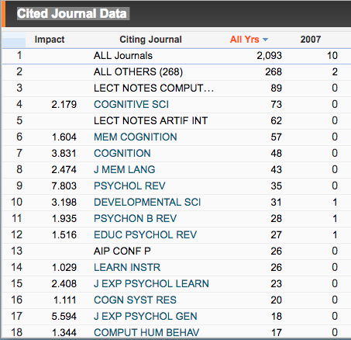

Actual text on Webpage Cited

COGNITIVE SCI

MEM COGNITION

COGNITION

J MEM LANG

PSYCHOL REV

DEVELOPMENTAL SCI

PSYCHON B REV

EDUC PSYCHOL REV

LEARN INSTR

J EXP PSYCHOL GEN

COMPUT HUM BEHAV

THINK REASONING

PSYCHOL SCI

BRAIN LANG

PSYCHOL BULL

DEV PSYCHOL

INT J HUM-COMPUT ST

COGNITIVE PSYCHOL

ETR&D-EDUC TECH RES

J LEARN SCI

CONTEMP EDUC PSY… (the dots are there but not clickable)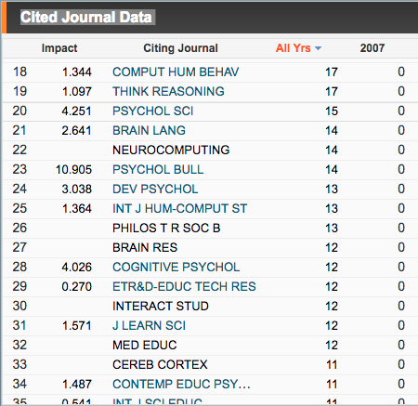

INT J SCI EDUC

J EDUC PSYCHOL

Q J EXP PSYCHOL

BEHAV RES METHODS

BRIT J PSYCHOL

COGN LINGUIST

COMPUT EDUC

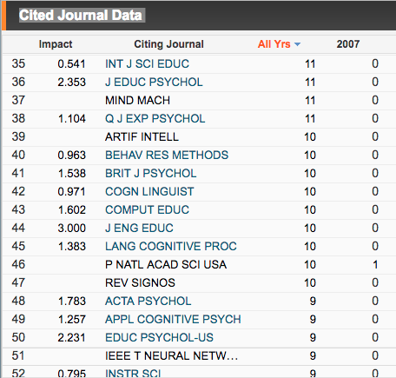J ENG EDUC

LANG COGNITIVE PROC



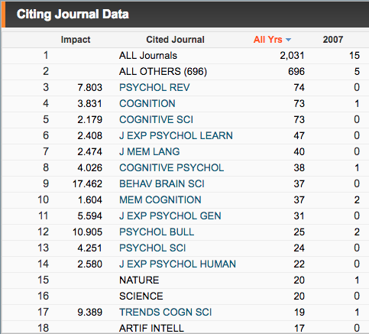

Citing List

PSYCHOL REV

COGNITION

COGNITIVE SCI

J EXP PSYCHOL LEARN

J MEM LANG

COGNITIVE PSYCHOL

BEHAVE BRAIN SCI

MEM COGNITION

J EXP PSYCHOL GEN

PSYCHOL BULL

PSYCHOL SCI

J EXP PSYCHOL HUMAN

TRENDS COGN SCI

J CHILD LANG

PSYCHON B REV

J COGNITIVE NEUROSCI

PSYCHOL LEARN MOTIV

AM J PSYCHOL

J PERS SOC PSYCHOL

LANG COGNITIVE PROC